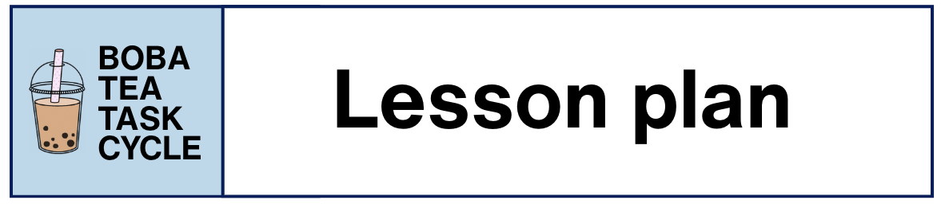

Task Cycle Overview
This task cycle was designed for an intensive program for US university students studying Mandarin. In the needs analysis, students expressed interest in preparing for study and work abroad opportunities in mainland China or Taiwan. The program curriculum included pedagogical tasks related to securing housing, navigating public transit, participating in cultural activities, and socializing.

In the boba tea task cycle, students prepare boba tea, instruct others to make tea, and create their own recipes. In many study abroad programs, students participate in cultural activities as part of extracurricular excursions. This task cycle provides an opportunity for students to use the language they would need to learn how to make boba tea from a tea master.

Age | College students
Proficiency Level | ACTFL Intermediate Low
ACTFL Communicative Modes | Interpersonal Speaking, Interpretive Listening, Interpretive Reading, Presentational Speaking
Main Tasks | - Prepare boba tea according to a recipe  - Design and defend a unique boba tea recipe
Time | Approximately 3 hours

Project Information and Video Resources
This task cycle is part of the Georgetown-STARTALK project. You can see parts of the task cycle in action in the Georgetown-STARTALK TBLT-C video. Visit our website to find the video and related resources: www.startalk.georgetown.edu


In this document, activities and tasks marked with this video icon and a timestamp indicate which parts are included in the video.

Pre-Task Phase
The pre-task phase includes four pedagogical activities. The pre-task activities are designed to activate students’ experiences drinking tea and to get students to use and think about relevant expressions and vocabulary.

Teachers may complete some or all of these activities depending on their context. Each activity takes 10–20 minutes to complete.

Pre-Task Activity 1: New Generation Tea
This full-group activity introduces students to a new boba tea fad through a YouTube video from a popular Chinese tea shop.

- The teacher projects a picture of a popular tea shop and asks the class if anyone has heard of this shop before.
- The teacher plays the video for students, prompting them to pay attention to what makes this tea different from other boba tea they have seen before.
- As the video shows the cheese tea top added to the drinks, the teacher asks students to share what they think is happening and what they think the white foam is, pausing the video to focus on key details of the tea preparation.
- After the video ends, the teacher then shows three cups of different kinds of Boba tea from the shop, describing each flavor and prompting students again to think about the white foam at the top of each cup.
- Students are prompted to make guesses and share amongst themselves what they think it could be.
- Students volunteer answers to share with the whole class and the teacher reveals the ingredients of cheese foam.

Pre-Task Activity 2: Four Corners
This full-group activity invites students to move around the classroom to show their preferences related to tea. The activity can last 10–20 minutes depending on the number of prompts, level of agreement in the class, and student engagement.

- Students are instructed to stand up and spread out around the room.
- The teacher provides a prompt asking students to select their tea preference (i.e., What kind of tea do you like? Oolong, black, green, don’t like tea)
- Each corner of the room represents a different preference. This direction is reinforced with a visual aid on the accompanying slide deck.
- Students move to the corner of the room that aligns with their preference.
- In the small groups that form in each corner, students talk about their choice with each other.
- The four corners are repeated with new prompts.
  - Example: What kind of milk do you like? Whole milk, 2% milk, Fat free milk, plant-based milk (coconut, almond, oat)

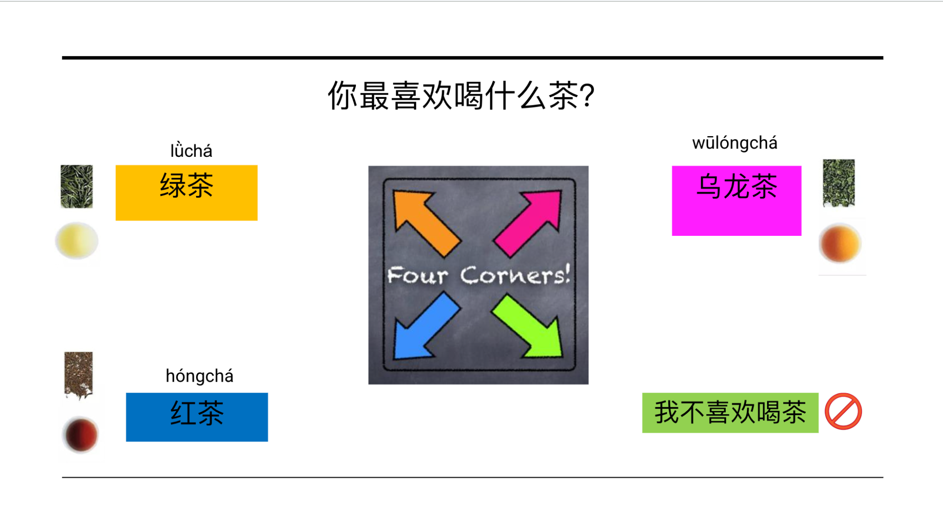

Pre-Task Activity 3: Guess the Item

See video 02:21

In this full-group activity, the students and teacher take turns asking and answering yes/no questions about fruits and vegetables.
- The teacher presents a slide with 10 images of different fruits and vegetables and tells the class to guess which one she is thinking of.
  - “The ingredient I am thinking of is…”
- Students take turns asking yes/no questions to identify which item she is thinking of.
- The first student to correctly guess the teacher’s item takes the next turn thinking of a mystery item for the class to guess.
- The game can continue for as many rounds as desired.

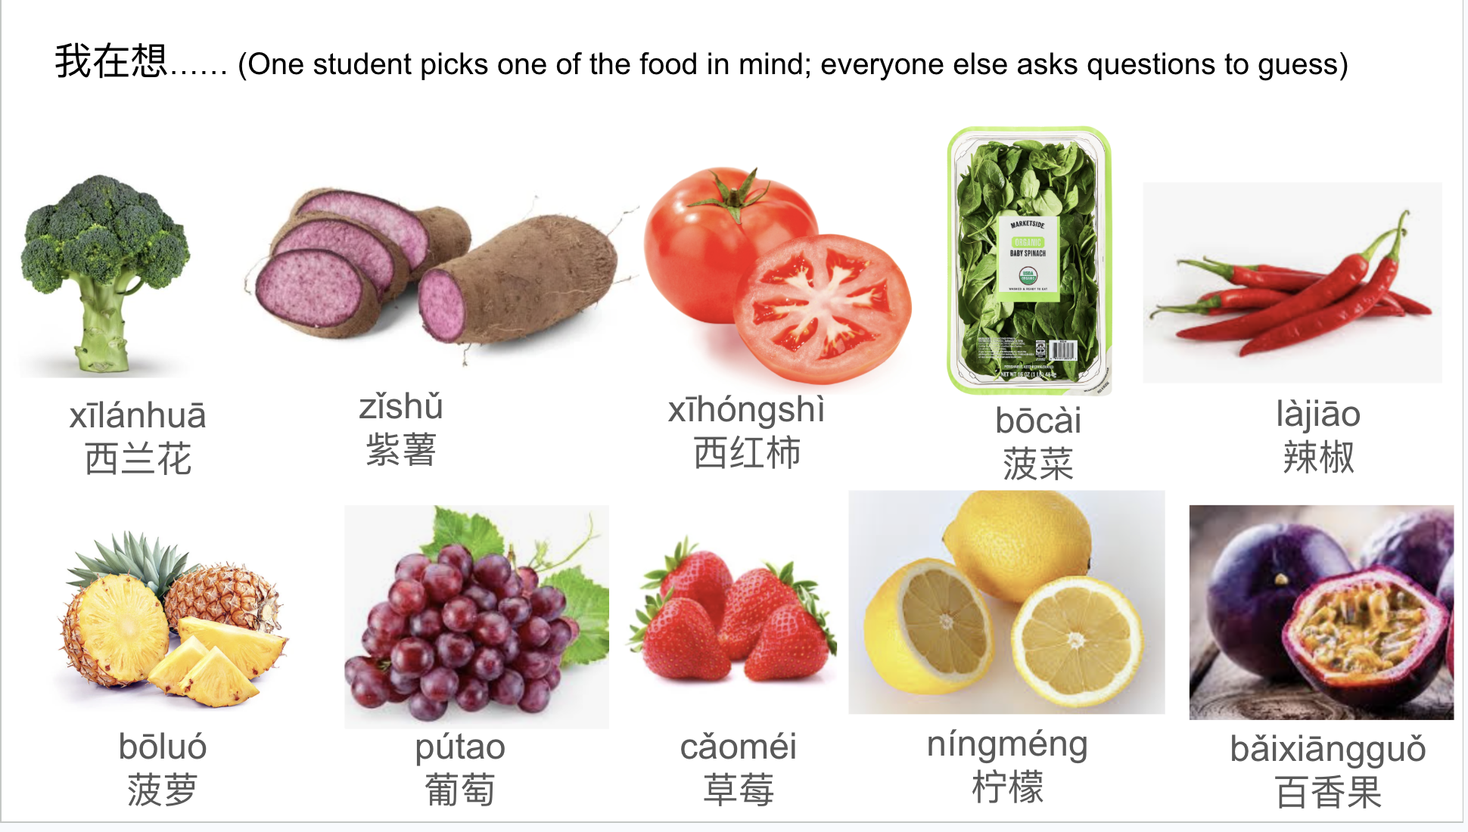

Pre-Task Activity 4: Sequencing Tea-Making Steps
In this small-group activity, students must work together to sequence the correct order of tea-making instructions.

Resource: Pre-Task Activity 4_Formatted.pdf

- Students work in groups of four. Half the groups will have recipe A and half will have recipe B.
- Print a set of six procedural steps for recipe A or B for each group. For both recipes, the steps are directions for making boba tea using “把” (bǎ) sentences. Cut the procedural list so that each step is listed on a separate strip of paper.
- Each group receives one complete set of procedural steps. Each student randomly selects one or two of the procedural steps.
- Students then take turns reading their steps out loud to their group and collaboratively deciding the sequence. Then, they form a line and each student holds their step(s). Students should stand in the order that they think is correct.
  - Note: If a group is stuck, they can ask the teacher for up to two clues. The clues are numbered audio recordings that are played aloud.
- Once the lines are formed, students check with other groups to see which groups have the same recipe (A or B).
- Once they find the groups, the students then check if they have sequenced the steps in the same way.
- The teacher will ask"做奶茶有几步" (How many steps for making a Boba tea?)，"第一步、第二步、……到第六步做什么?" (What do we do from the first step to the sixth step?). Students will then report one sentence each.

Main Task Phase
The main task phase includes two tasks. The two main tasks are topically related and use shared materials, but are independent from each other. Both main tasks are designed to reflect target tasks in a study abroad context.

Main Task 1: Boba Tea-Making Class

See video 04:33

Task type: Output-based, information-gap task
Duration: 25 minutes
Resource: Main Task 1_Round 1 and 2 Recipes_Formatted.pdf

Task Summary
This is a role-play, information-gap task. It simulates visiting a boba tea-making class as a cultural activity during study abroad.

Students will work in small groups of three to four. They will follow instructions for making boba tea.

Task Materials
Each small group will receive one set of materials. Before the task begins, prepare the following for each group:
- One set of ingredients, printed in color, cut out, and placed in an envelope
- Three plastic cups of different sizes (small, medium, and large)
- A boba tea straw
- Printed information-gap boba tea recipes (3)
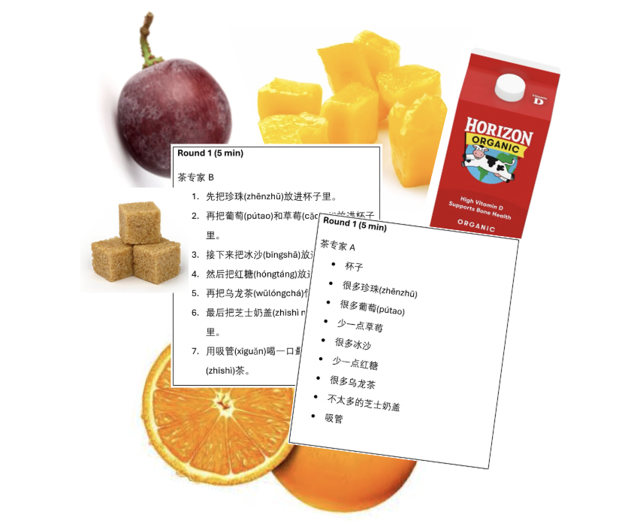

Task Directions
- Pass out the task materials to each group. Students should open the envelopes and place the ingredients and cups on the table.
- Explain to the class that two students will play the role of “tea master” and one or two students will play the role of “trainee” (i.e., study abroad student). The trainee(s) are learning to make tea.
- The two tea masters must work together to tell the trainee(s) the steps for making boba tea. One tea master has the ingredient list and the other has the steps. They cannot view information from the other tea master’s recipe.
- The trainee(s) must listen to the recipe from the tea masters and add the cut-out paper ingredients to the plastic cup in types and quantities that match their instructions.
- Once the groups have completed the first recipe, as a whole class, check to make sure the right ingredients in the right quantities ended up in the cup and help resolve discrepancies among tea masters and trainees.
- Rotate trainee(s) and tea master roles two more times to make sure each student has a chance to play each role.
  - Note: To create an additional challenge, add a speed component where groups have to race to complete the recipe before other groups.
- During the task, the teacher walks around to each group and helps students if they ask for clarification or support with vocabulary.

Main Task 2: Boba Tea Investment Opportunity

See video 07:10

Task type: Output-based, decision-making task
Duration: 50 minutes

Task Summary
The small groups of three to four students work together to invent a new Boba tea recipe. Then, groups compete against each other for funding from investors.

Task Materials
Each small group will use the printed ingredients and cups used in Main Task 1. There are no printed instructions in this round because students are designing their own recipes. Groups are invited to document their final recipe in whatever form will allow them to present the recipe in a clear and compelling way to the "investors" at the end of the task.

Task Directions
- Students should place the ingredients and boba tea cups on the table.
- The teacher will present the class with the following scenario:
  - The Coca Cola company learned that a group of genius students are creating new tea recipes. The board of directors (董事会，dǒngshìhuì) is coming to hear your pitch and will select one of your recipes to invest $50,000 to start a new tea line.
  - Each group must invent a recipe that you think will be the best. You can draw inspiration from the past recipes and the ingredients you have. First, work as a group to create the perfect recipe. You will have 5 minutes. Next, your group will present your step-by-step recipe to the class and explain why you think what you made will be a good investment. Finally, the class will vote for THREE awards: most delicious, most likely to make someone sick, and most likely to go viral. The group awarded “most delicious” wins the investment bid.
- Allow students 5 minutes to invent a new recipe in small groups. Students will use the printed ingredients and a cup to assemble their recipe.
- Next, each group will present their recipe and explain why it should be selected for funding. Give students time to prepare as a group to speak to the whole class. Then, call on each group to present.
- The teacher facilitates a voting session to determine the winners of the three award-winning recipes. Students are not allowed to vote for their own recipe, and can only cast three votes (one for each of the awards).

Post-Task Phase
The post-task phase includes four pedagogical activities that focus on language refinement and cultural awareness.

Teachers may complete some or all of these activities depending on what is most useful and feasible for their context. Each activity takes approximately 5–10 minutes to complete.

Post-Task Activity 1: Fill-in-the-Blank Vocabulary
In this small group activity, students work together to recall key words and phrases needed to place a boba tea order.

- The teacher passes out a worksheet with five trios of words. Each trio is thematically related in some way (e.g., size of cup) and missing one of the three words.
- Students work in small groups to complete the incomplete trio of words and phrases.
- The teacher facilitates a review of the worksheet answers and addresses any questions that came up related to characters, tone, etc.

Post-Task Activity 2: Vocabulary Matching

See video 11:56

In this small group activity, students work together to recall key words and phrases needed to place a boba tea order.

- The teacher presents students with a list of words and phrases in English and a list of words and phrases written in Mandarin (with pronunciation as needed). Together, the class reads each of the Mandarin words/phrases out loud.
- In small groups, students work together to match the English and Mandarin words together based on their definitions.
- The teacher shares the correct answers with the class and students compare their work, making corrections as needed.

Post-Task Activity 3: Payment Methods in China
In this full-group activity focused on building cultural background knowledge, the teacher introduces the most common payment method in China.
- The teacher presents pictures to compare two payment methods: paying with cash and by paying by scanning a QR code (扫码，sǎomǎ). The teacher explains that QR code payment is now widely used in China.
- The teacher asks the class about the mobile applications (e.g., Wechat, Alipay) that are used in China for payment, and students answer based on their previous knowledge.
- The students talk about whether scanning QR code to pay is also prevalent in the U.S..
- More applications used for daily life (e.g., Douyin, Bilibili, Amap, Line, etc.) are presented to students.

Post-Task Activity 4: Grammar-focused Exercises
In this activity, students work together in small groups or as a class to focus on language accuracy. Exercises can be selected based on grammatical structures that emerged during the main tasks.

4.1 Spot the Errors
- The teacher presents a series of incomplete sentences related to making or ordering boba tea. The sentences are provided in Mandarin scripts and pronunciation. (Note: The instructor should generate these sentences based on student errors or error patterns noted during the main tasks.)
- Students work in small groups to review the six sentences, identify the errors, and propose corrections.
- The teacher circulates while students are working in small groups to provide clarification and support.
- The class reviews the sentences together one by one, with groups volunteering the different errors they found and the corrections they propose.
- As needed, the teacher also explains subtle differences in expressions with similar meaning.

4.2 Match Up
- The teacher presents five English sentences on the left and a list of corresponding sentences on the right, using the target grammar in Mandarin scripts and pronunciation but in a random order.
- The syntactical structure of the target grammar is also presented on the slide.
- The class works together to match up sentences in two languages. Students volunteer to read the Mandarin sentence aloud.

4.3 Which Order Is Correct?
- The teacher presents 3 structures using conjunctions to express doing actions in sequence with different possible combinations. Only Mandarin scripts and pronunciation are given.
- Students make a judgement about each structure and then vote on the correct one(s) based on their own knowledge. (The three choices were all correct actually.)
- The teacher tells them everyone’s answer is correct and students ask questions about the grammar.

